



Liquiloans Junior Analyst assignment

BY- Hariom rai

22-Feb-2022

Project/Programme Name | Liquiloans Junior Analyst assignment
Project Sponsor | Great Learning
Project/Programme Manager | Sanket Bhatia
Start Date | 21/02/2022 | Completion Date | 22/01/2022

Part 1: Project Closure

Purpose of the project
The purpose of this project is to analyze a warranty claims dataset to gain insights into the products, issues, and regions/countries with the most warranty claims, as well as how various factors such as agent tenure and contact type affect the claims. The ultimate goal is to provide actionable recommendations for business decisions that can help reduce the number of claims and improve customer satisfaction.

Objectives achieved/not achieved
Based on the information provided, the objective of the project was to analyze warranty claims data and identify patterns and trends in customer issues and product types. Some of the objectives achieved in the project include identifying the product types with the highest number of warranty claims, determining the most common issues reported by customers for each product type, and analyzing the average agent tenure over time for each product type. Additionally, the project involved data cleaning, missing value imputation, and data visualization using Python libraries such as Pandas, Seaborn, and Matplotlib.
Results: Overall, the project was deemed successful in achieving its objectives and expectations.

Outstanding Risks and Issues
Risks: Besides the possibility of messy data due to the high volume, collecting meaningfull data, selecting the right analytics tool, data visualization, low-quality data, scaling challenges, data security, lack of a data culture, and inaccessibility.
Issues: Potential privacy concerns from stakeholders, potential for technical difficulties during the course of the project, and potential for operational issues arising from data processing.

Post project review
Timming is very Limited, Data is very inconsistant

Planning and control
Planning By steps:
- Data cleaning and preprocessing
- Data exploration and analysis

Part 2: Project steps

Data PReprocessing

- IMPORTING THE L
- ibraries
IBRARIES
First we have to imports necessary packages for data analysis and visualization, including pandas for data manipulation, numpy for numerical computing, seaborn for data visualization, and matplotlib.pyplot for creating plots.
- IMPORTING THE CSV FILE
We use the pd.read_csv() function to read a CSV file and convert it into a Pandas DataFrame, which we can then use to perform various data manipulation and analysis tasks. In the given code, the pd.read_csv() function is used to read the CSV file located at the specified file path and store the resulting DataFrame in the variable dataset.
- MAKEING A COPY OF DATASET
Creating a copy of the dataset is a good practice to avoid accidentally modifying the original data. By creating a copy, we can work on the data without affecting the original dataset. This is particularly important when we are cleaning, transforming, or processing the data. If we make any mistakes during the analysis, we can simply discard the copy and start over again with the original dataset. It also helps to keep the code more organized and easier to read.
- DROPING DUPLICATES
We drop duplicate values in a dataset to ensure that each observation or row is unique. Duplicates can occur due to various reasons such as data entry errors, system errors, or merging of datasets. By removing duplicate values, we can avoid counting the same observation multiple times and obtain accurate results during data analysis. Out of total 100000 rows 13464 rows are duplicates so we deleted these duplicated row using above function
- COUNTING NULL VALUES AND DROPING COLUMNS IN WHICH 30% OR MORE NULL VALUES ARE PRESENT
We make the count of null values in percentage to understand how much missing data we have in each column, as missing data can affect the accuracy of our analysis. We dropped the columns with more than 30% null values because they may not provide meaningful insights and can also increase the computational cost of the analysis. Dropping such columns can also help to reduce the risk of overfitting the data.
- CHANGING DATATYPE OF CONTACT_TYPE COLUMN
The reason for changing the datatype of the contact_type column to string and making the values title case is to ensure consistency and uniformity in the values of this column.
In contact_type column there is voice, Voice this type of values so we have to bring equal so that first I used str function and bring values inside the columns in proper case so I used title function
- CHANGING IMPORTANT DATES COLUMNS IN DATE DATATYPE
Date is given in number format like 201826 in this case changing important date columns into the date datatype has several benefits. Firstly, it makes it easier to perform date-based calculations and analysis. For example, we can calculate the number of days between two dates, the month or year of a specific date, or even create new variables based on specific date ranges. Secondly, it helps to maintain consistency and accuracy in the data, as we can ensure that dates are recorded in the correct format and avoid errors that may occur due to data entry mistakes. Lastly, it makes it easier to visualize data over time using various types of charts, such as line charts, bar charts, or heatmaps, which can help to identify trends, patterns, or anomalies in the data.
- FILLING NULL VALUES OF REGION COLUMN
We filled null values of region column by mode in order to replace the missing values with the most frequent value in that column. This helps to ensure that we have complete data for that column, which can be useful in subsequent analysis or modeling. Filling null values with the mode is a simple method of imputation that can be effective when the missing values are believed to be missing at random.
- FILLING NULL VALUES OF PRODUCT_TYPE COLUMN COLUMN
We filled the null values of the product_type column by mode because the product_type column is categorical and represents the type of product for which the warranty claim was made. Since the null values were less than 1% of the total data, it is safe to assume that the mode (most frequently occurring value) of the product_type column is a reasonable estimate for filling the null values. This helps to ensure that we have complete data for analysis and modeling.
- FILLING NULL VALUES OF AGENT_TENURE_INDAYS COLUMN
We fill Null values of the agent_tenure_indays column by median because median is a more robust measure of central tendency than mean and is not influenced by extreme values or outliers. Filling null values with the median can help prevent any biases or distortions in the data analysis that might result from using the mean value, which is more sensitive to extreme values or outliers.
- FILLING NULL VALUES OF CONTACT_TYPE COLUMN
Filling null values of the contact_type column with mode is done in order to replace the missing values with the most frequent value in the column. This is done to ensure that the dataset remains accurate and complete, and to avoid any errors or bias that may arise due to missing data. The mode is used as it represents the value that occurs most frequently in the dataset, making it a reliable estimate for filling the missing values.
- FILLING NULL VALUES OF COUNTRY COLUMN
Filling null values in the country column by mode and taking reference by region is done to fill the missing values of country column based on the most frequently occurring country in the same region. This is a common approach to fill missing categorical data where the values of a missing entry are predicted based on the most common value in the same category.
- FILLING NULL VALUES OF ISSUE_TYPE COLUMN
Filling Null values of issue_type column by mode and taking reference from product_type and region helps to ensure that the most common issue type for a specific product type and region is assigned to the Null values, thereby providing a more accurate representation of the data. This approach ensures that the analysis based on issue_type is not biased due to missing values.

Data Analysing

- Which product type has the highest number of warranty claims?
First we have to group the dataset by product_type and calculate the sum of parts_ct for each product type. Then it will plot a bar graph showing the number of warranty claims for each product type. Then it will print the product type with the highest number of warranty claims.
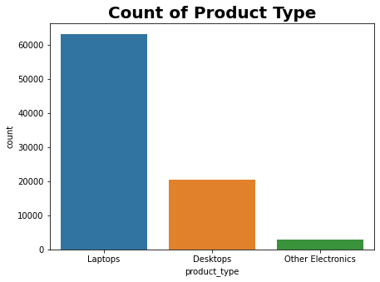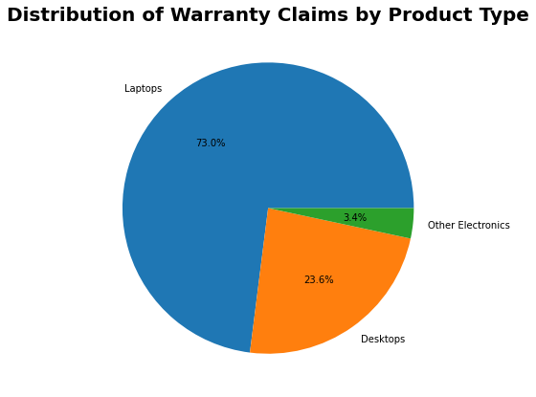
Product type with the highest number of warranty claims: Laptops
The product type with the highest number of warranty claims can give insights into which product line needs the most attention for improvements or quality control. This information can be used to prioritize resources towards improving that particular product line to reduce warranty claims, increase customer satisfaction, and ultimately drive revenue growth.

- What is the most common issue reported by customers for each product type?
First we have to groups the data by product type and issue type, and then counts the number of occurrences for each group. The code then extracts the group with the highest count of occurrences for each product type. Finally, it plots a horizontal bar chart to show the most common issues reported by customers for each product type.
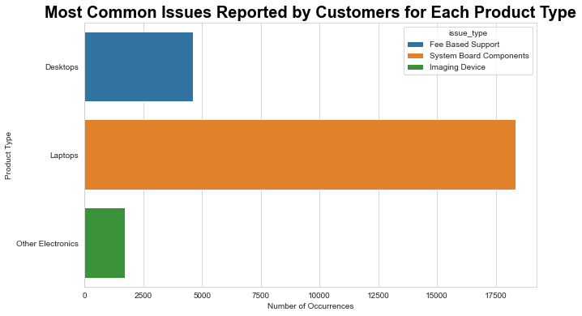
This information can be useful for identifying areas that may require improvement in the product design or manufacturing process. It may also help customer service representatives to better understand and anticipate the types of issues that customers are most likely to encounter with each product type.

- which is the heighest medium of contact.
First we have to creates a countplot to display the frequency of each contact type used by customers. In this dataset we have a column "contact_type". So we will use this "contact_type" column to create the countplot.
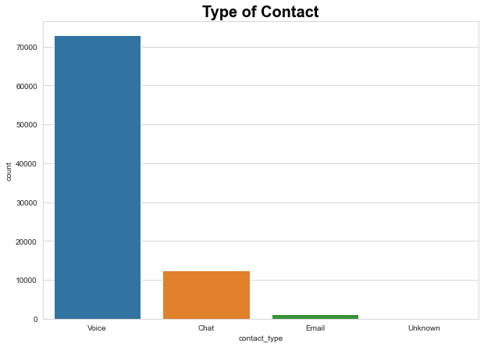
Voice has the heighest medium of contacts
This countplot shows that the most common way customers contact the company is through the voice , followed by chat and then through the Email. There are a very small number of customers whose information is not available.
The observation made from this countplot is that the company might need to ensure that their voice support is robust and efficient since it is the most popular way of contacting the company. They could also consider improving their chat and email support to cater to more customers.
4. Correlation in the dataset
Correlation is a statistical measure that expresses the extent to which two variables are linearly related. First we use dataset.corr() code to calculates the correlation matrix of the numerical columns in the dataset, while sns.heatmap() plots a heatmap of the correlation matrix using a color scale where positive correlation is represented by red color and negative correlation is represented by blue color.
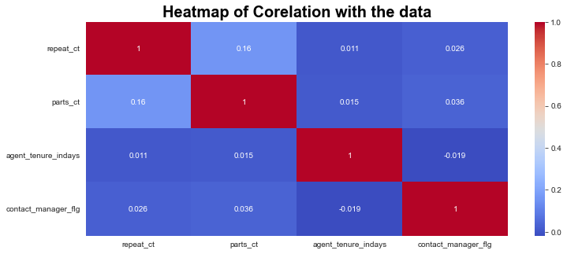
The observation from the Heatmap is that there is a weak positive correlation between 'repeat_ct' and 'parts_ct', while there is no significant correlation between 'agent_tenure_indays' and any other variable. Additionally, there is a weak positive correlation between 'parts_ct' and 'contact_manager_flg'.
5. Plot the graph for types of repair
Hardware is used most for repair as compare to software
The sns.countplot() function from the Seaborn library is used to create the plot, with the x parameter set to the repair_type column of the dataset.

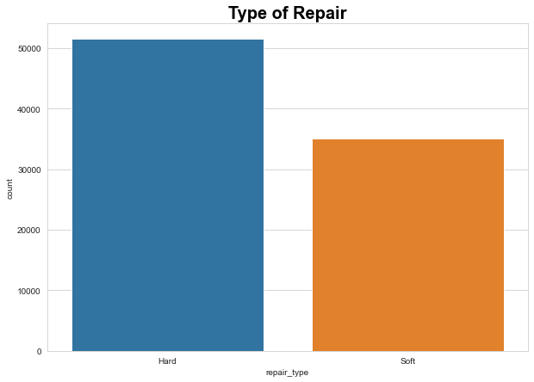
The resulting plot shows that the most common type of repair is "Hardware," followed by "Software". This information could be useful for identifying areas where the company might want to focus its efforts, such as investing in more hardware repair specialists or developing more robust software repair solutions.
6. What is the average agent tenure in days for each product type?
The average agent tenure in days is calculated for each product type using the groupby function. The resulting data is then sorted in descending order and plotted as a horizontal bar chart using sns.barplot. The chart shows the average agent tenure in days for each product type, with the product type with the highest average tenure at the top of the chart..
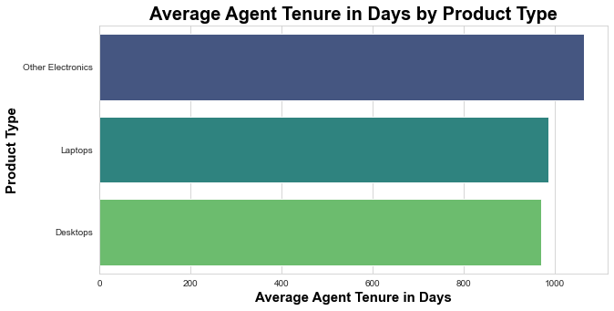
The result shows the average agent tenure in days for each product type, calculated using the groupby() function. The product type with the highest average agent tenure is "Other Electronics" with 1063.14 days, followed by "Laptops" with 984.90 days, and "Desktops" with 970.13 days. This information can be useful for identifying patterns in agent tenure across different product types and potentially improving training or support for agents working with certain products.
7. What is the trend in the number of warranty claims over time?
I grouped the data by the month of manufacture date and calculates the total number of repeat warranty claims for each month. It then creates a line chart to visualize the trend in the number of warranty claims over time. The x-axis represents the month of manufacture date and the y-axis represents the number of warranty claims. The chart shows the trend in the number of warranty claims over time.
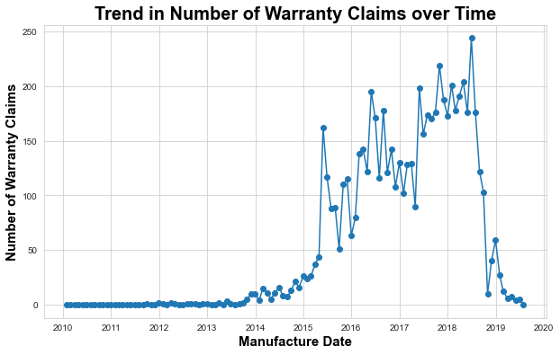
The line chart shows the trend in the number of warranty claims over time. It appears that there is a significant increase in the number of warranty claims in the early months of 2014, And reaches its peak on mid 2018. After that, there is a gradual decline in the number of claims until the end of the year. Overall, the trend indicates that there may be some issue with the products manufactured during the early months of 2014, which led to a surge in warranty claims.
8. Are there any specific regions that have a higher number of warranty claims than others?
Region where heighest number of warranty claimed is: Hogwarts
In this question first we have to grouped the data by region and the total number of warranty claims in each region is calculated. Then, a bar chart is created using seaborn to visualize the number of warranty claims by region. The region with the highest number of warranty claims will be printed as output.

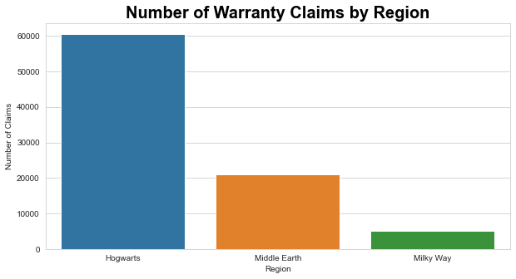
The output will shows a bar chart of the number of warranty claims by region, where "Hogwarts" has the highest number of warranty claims (60,541), followed by "Middle Earth" (20,904) and "Milky Way" (5,091).
9. Is there a relationship between the number of parts sent and the product type?
First we create boxplot

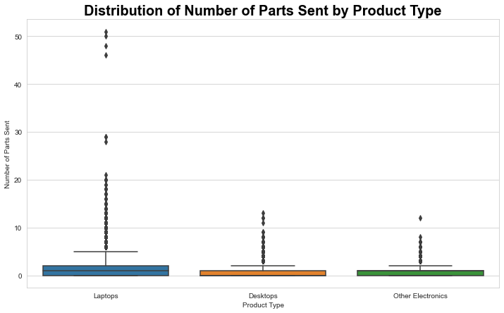
The box plot shows that laptops have the highest median number of parts sent, followed by desktops and other electronics. Laptops also have a wider range of parts sent values, with more outliers compared to the other two product types. Overall, the distribution of parts sent values for desktops and other electronics are similar.
10. What is the distribution of contract start and end dates?
Created a histogram using plt.hist function.
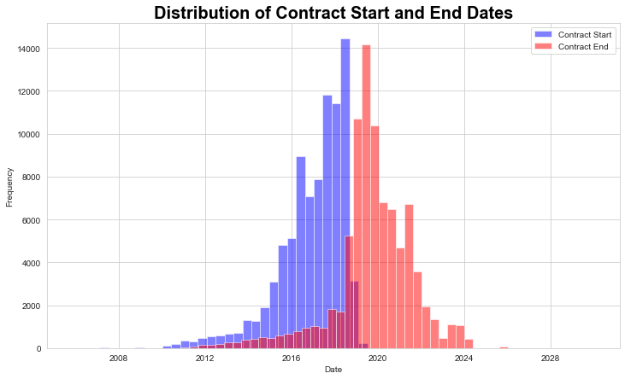
This code generates a histogram of the contract start and end dates for the dataset. The blue bars represent the frequency of contract start dates and the red bars represent the frequency of contract end dates. The graph shows that the contract start and end dates are mostly concentrated within the range of 2016 to 2022. However, there are some contracts that started or ended in earlier or later years as well. Overall, the distribution of contract start and end dates is relatively even, indicating that contracts have been signed and ended at a relatively steady pace throughout the dataset's time range.
11. Is there a relationship between the number of parts sent and the repeat count for each product type?
We have to plot a scatter plot for the number of parts sent vs repeat count, It is using the seaborn library.
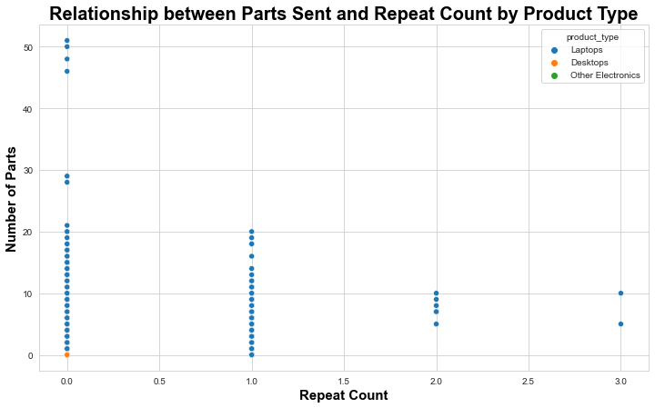
The scatterplot shows the relationship between the number of parts sent and the repeat count for each product type. But the relationship is shown on Product_type of laptop only. And others product_type don’t have relationship. Each product type is represented by a different color. So Overall, there seems to be a positive relationship between the number of parts sent and the repeat count, with higher repeat counts associated with higher numbers of parts sent but only for laptop.
12. Is there a relationship between the number of parts sent and the repeat count for each product type?
First we have to groups the dataset by product type and repeat count, calculates the sum of parts sent for each group, and stores the results in a new DataFrame called grouped_df. It then creates a line chart using seaborn's lineplot() function to visualize the relationship between parts count and repeat count for each product type. The chart has the repeat count on the x-axis, parts count on the y-axis, and different colors for each product type. The title and axis labels are also set. Finally, the chart is displayed using plt.show().
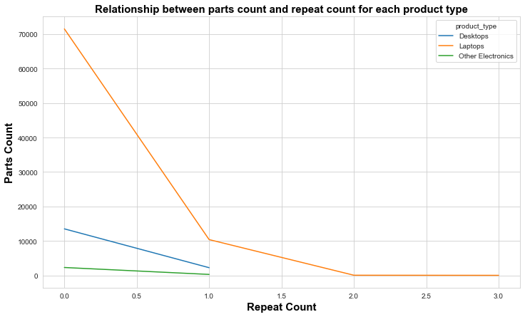
The line chart shows the relationship between parts count and repeat count for each product type. Desktops have a lower parts count than laptops and little heigher than other electronics. Laptops have a slight increase in parts count as repeat count increases, while other electronics have a small parts count increase for repeat count of 1.

